



Data Structures & Algorithm
LAB MANUAL

Disclaimer: The content is curated from online/offline resources and used for educational purpose only
Hash Table with Chaining

Objective:
To implement a hash table using chaining to resolve collisions.
Equipment Required:
- Computer with Python installed, text editor/IDE.

Prerequisites:
- Basic Python programming skills
- Hashing concept, modulo operator, lists.
Problem Statement:
Insert keys into a hash table using modulo method and resolve collisions using chaining.
Procedure:
- Initialize a list of empty buckets.
- Define a hash function using modulo.
- Insert keys into appropriate buckets.
- Print the entire hash table.

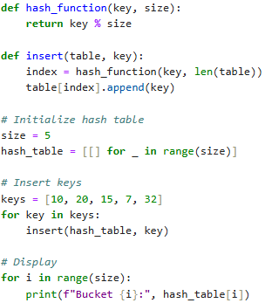

Output:
